Title: **Electromagnetism** Worksheet: 20

Course: Electrical Applications Unit: Electrical Theory CLO: 3

Name _________________________ Grade ________ Date ______________

**Objectives**

1. Student shall determine the magnetic rotation given the direction of current.
2. Student shall analyze that value of a Wheatstone bridge in appropriate field applications.

**Assessment**

Students shall demonstrate a comprehension of the objectives listed above by scoring a minimum of 75% on this Worksheet. Grading shall be based on an answer key.

**Theory**

The right-hand grip rule (1) states that if you point your thumb in the direction of *conventional current*, the remaining fingers of the right hand will wrap around the conductor in the direction of the magnetic rotating field.

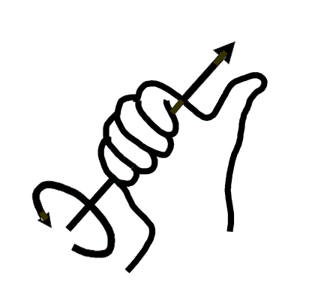

The right-hand grip rule (2) states that if you point your fingers in the direction of *conventional current* of a coil, the thumb of the right hand will point in the direction of the *lines of force*. If the core is straight then the thumb will point towards the north pole. (lines of force exit the north pole)



**Instructions**

Answer the following questions based on the graphics provided.

|  |  |  |  |
| --- | --- | --- | --- |
|  |  |  |  |
| * Correct * Incorrect | * Correct * Incorrect | * Correct * Incorrect | * Correct * Incorrect |

**Instructions**

Label the following figures with the correct north and south poles.

|  |  |  |
| --- | --- | --- |
|  |  |  |

**Instructions**

Label the following figures with the correct positive and negative connections base on the poles given.

|  |  |  |
| --- | --- | --- |
|  |  |  |

**Evaluation**

1. The direction in which the electromagnet is wound has no bearing on the induced north and south poles.
   1. True
   2. False
2. The direction of the rotating magnetic field around the winding wire determines the north and south poles on an electromagnet.
   1. True
   2. False
3. What ultimately determines the poles on an electromagnet?
   1. The direction the wire is wound
   2. The polarity of the source voltage
   3. How the core is rotated
   4. a and b
   5. All the above
4. An electromagnet is a permanent magnet.
   1. True
   2. False
5. An electromagnet should not be energized too long since the copper in the winding wire could become magnetized.
   1. True
   2. False
6. Magnetic lines of force weaken as they extend out from the magnet.
   1. True
   2. False
7. The two basic laws of magnetism are unlike poles attract and like poles repel.
   1. True
   2. False